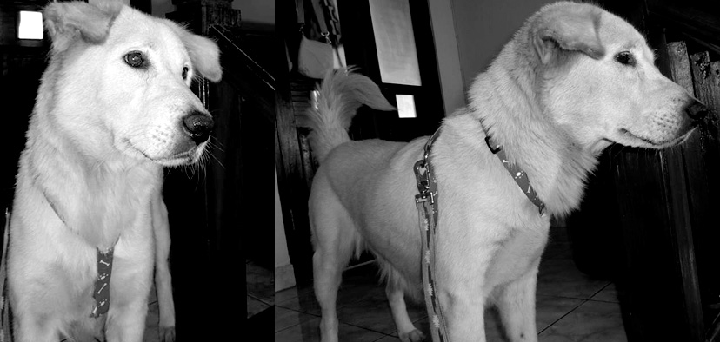

DITEMUKAN

FOUND

**Betina Jantan**

**Umur  
Jenis  
Corak**

**Ramah**

Ditemukan di (*insert location address, area and landmark)*   
Date: *Insert date here*

Found at *insert location address, area and landmark*   
Date: *Insert date here*

**Female Male**

**Age**

**Breed  
Colour**

**Friendly**

**TELEPON or SMS   
0812 XXXXXXXX or 0821 XXXXXXX**